Chapter 5 programming practice

# LRU page replacement algorithm

Given the common.h

## Common.h

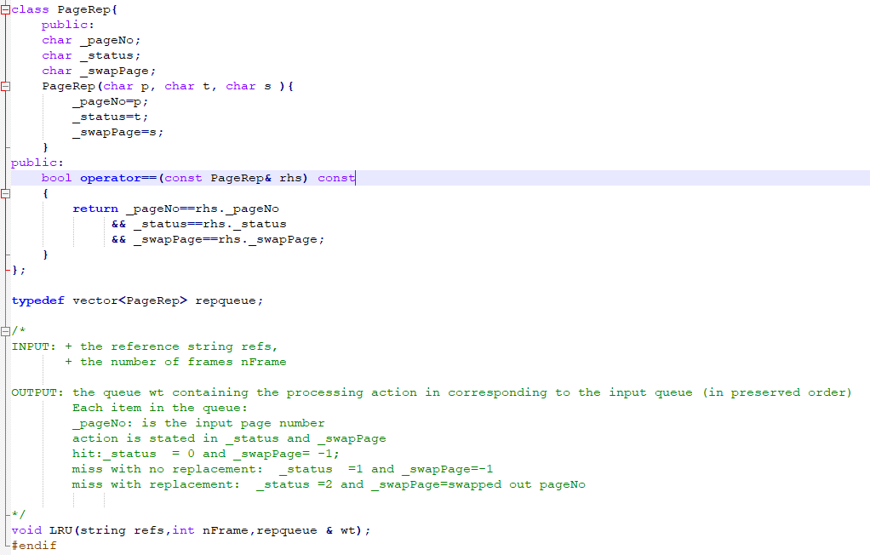

The procedure Access is what you have to program.

/*

INPUT: + the reference string refs,

+ the number of frames nFrame

OUTPUT: the queue wt containing the processing action in corresponding to the input queue (in preserved order)

Each item in the queue:

_pageNo: is the input page number

action is stated in _status and _swapPage

hit:_status = 0 and _swapPage= -1;

miss with no replacement: _status =1 and _swapPage=-1

miss with replacement: _status =2 and _swapPage=swapped out pageNo

*/

void LRU(string refs,int nFrame,repqueue & wt);

## main.cpp

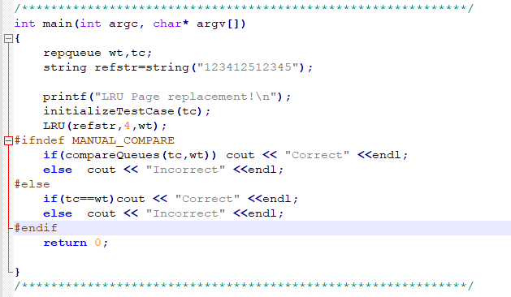

This contains the variable declaration and test case.

## Makefile

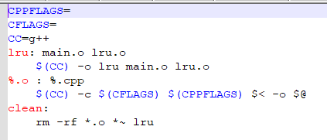

# Problem

Write the void LRU(string refs,int nFrame,repqueue & wt); procedure in the lru.cpp file